Please use a [free Google] virtual machine in a cloud data center with a public IP address as the lighthouse to set up the connectivity for computers behind NATs

Recommendations:
0. https://cloud.google.com/free/docs/free-cloud-features#compute
ionos.com
https://bandwagonhost.com/

1. https://github.com/slackhq/nebula

2. use a data comparison utility such as Meld and [Beyond Compare] to compare the configuration files attached to see where the changes should be made.

3. configure the config.yaml for the lighthouse and all participating computers.

PROCESS
1.download nebula-windows-amd64.zip from github
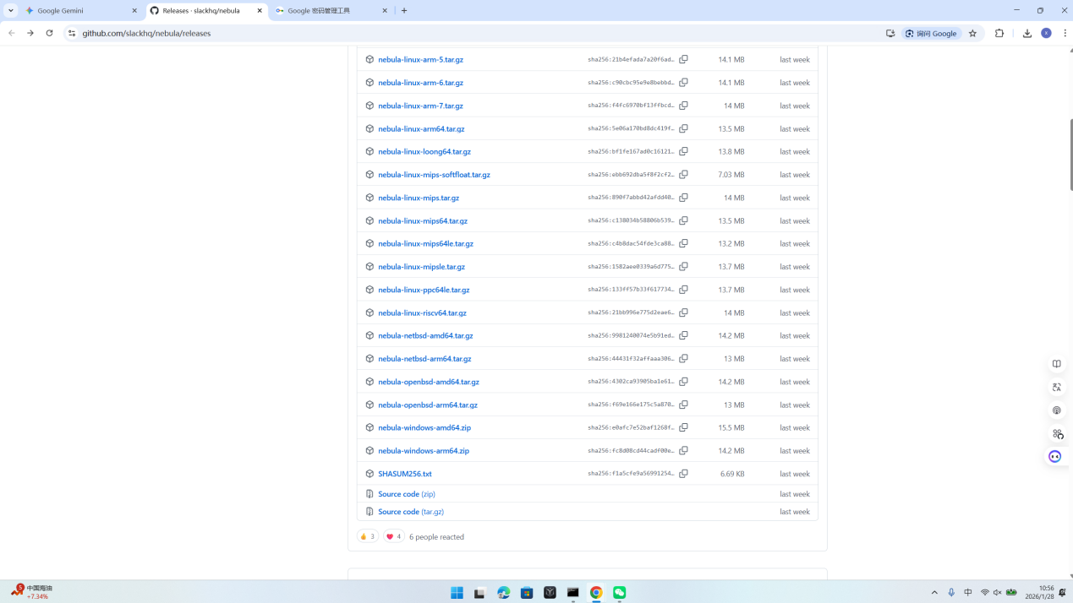
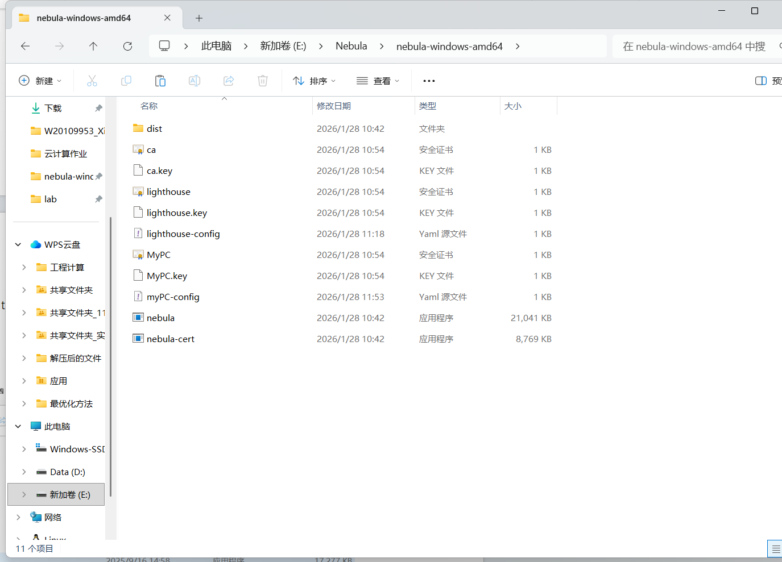
- config and save the config.yaml
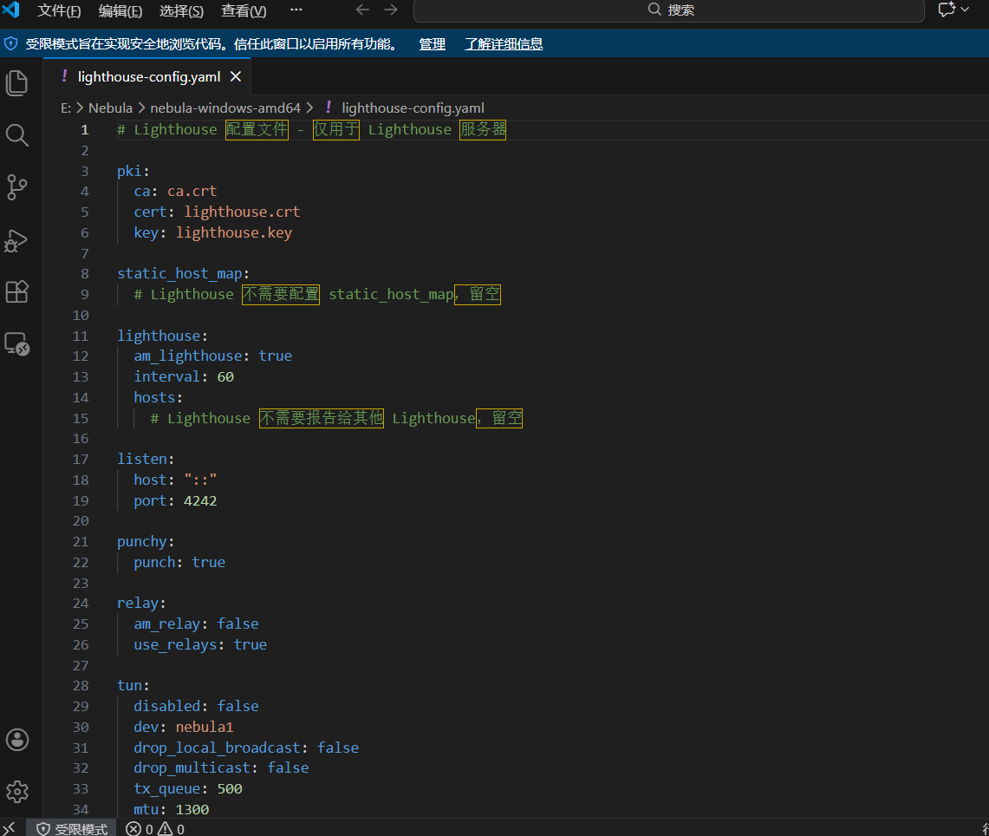
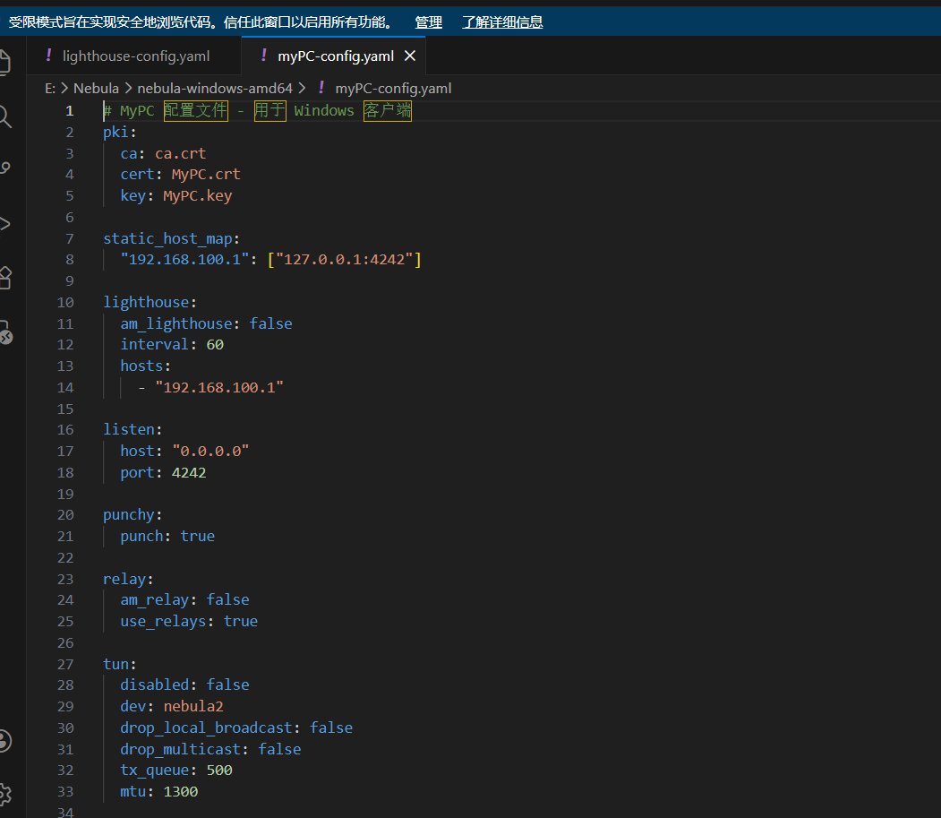

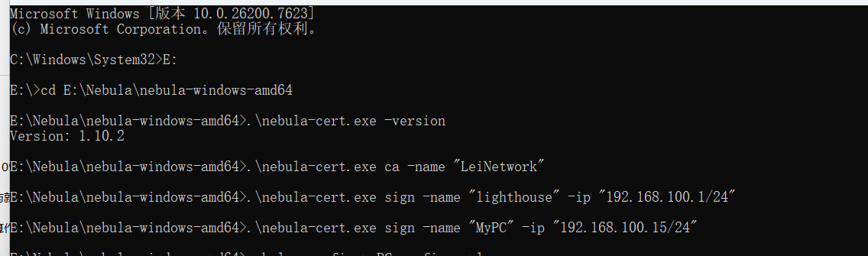
- config the cmd

4.nebula -config lighthouse-config.yaml
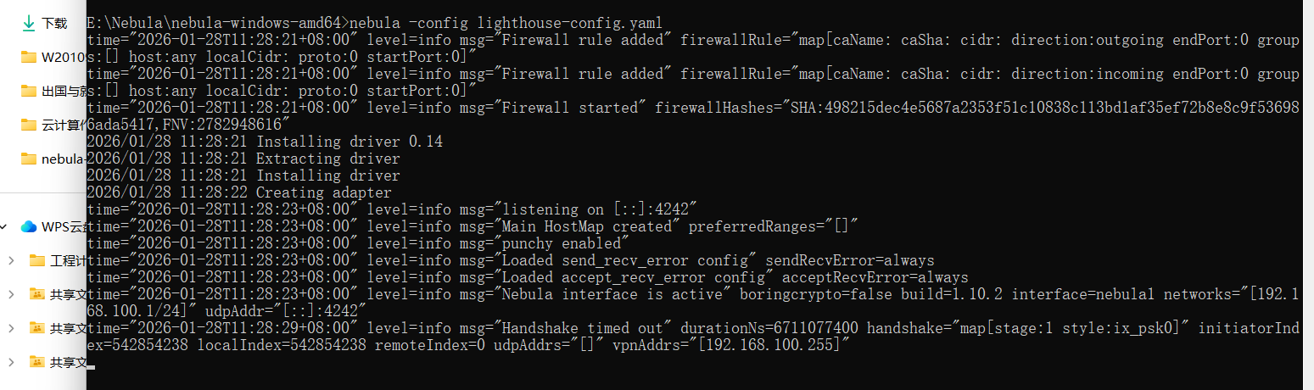
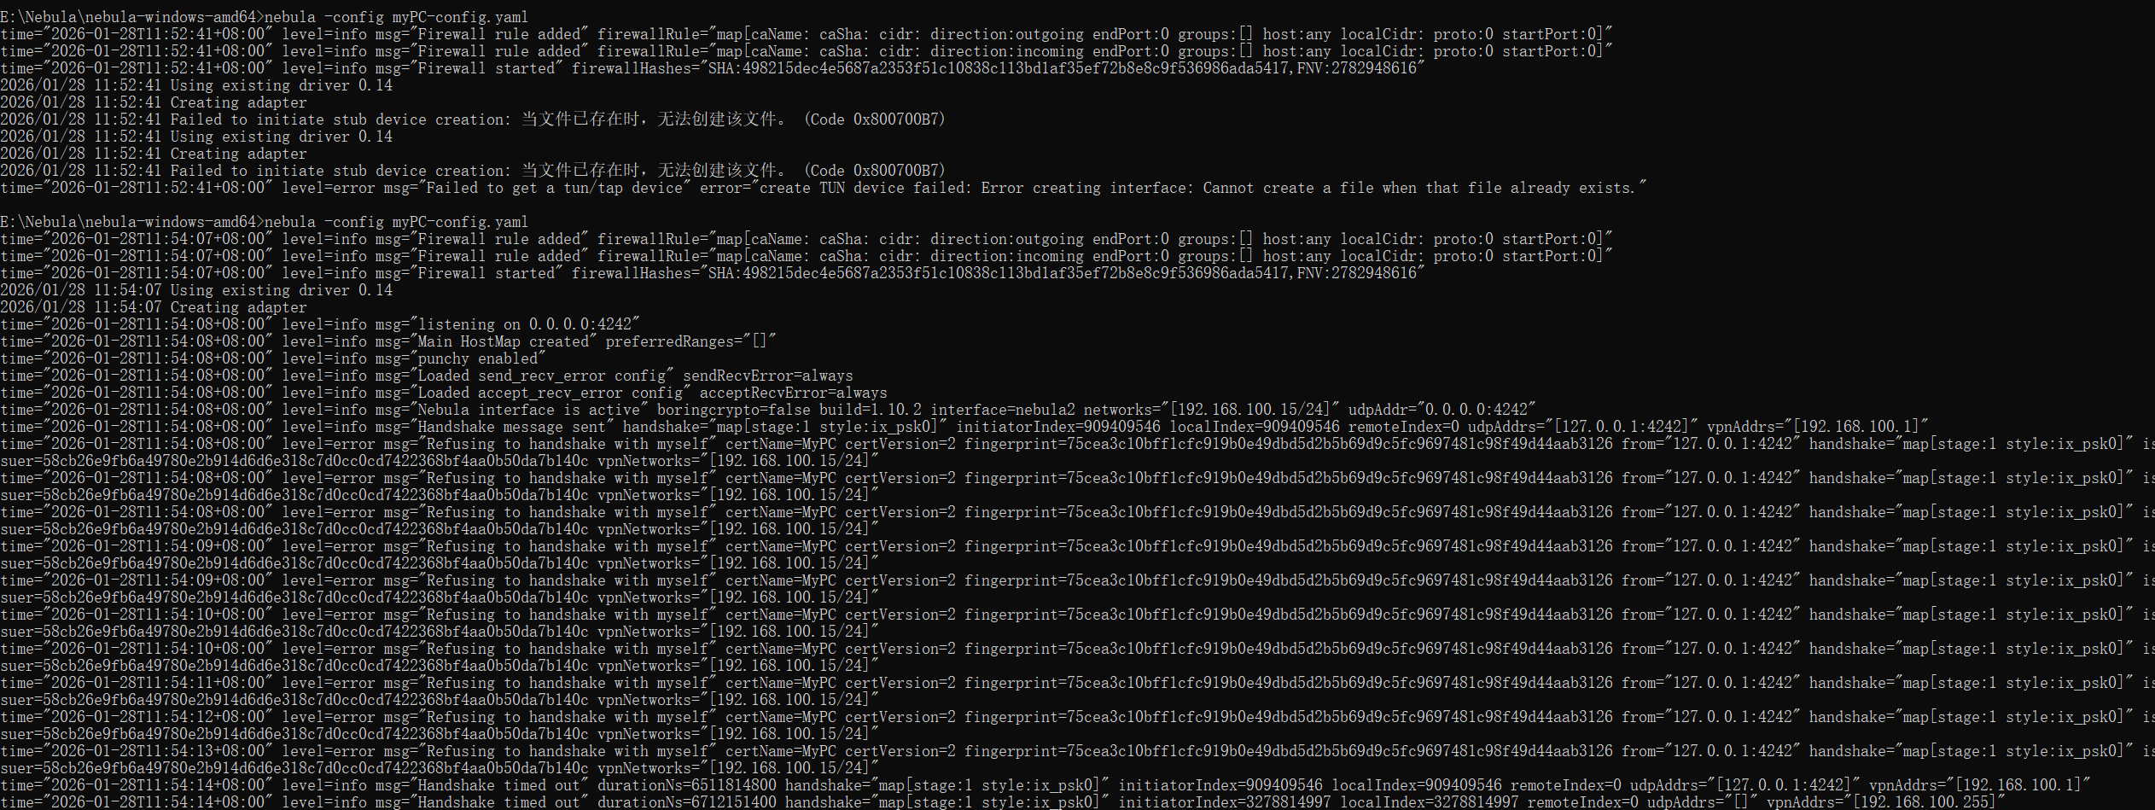

- Ping

